**Departmment of Electronics & Telecommunication Engineering**

**University of Moratuwa**

|  |  |  |
| --- | --- | --- |
| Course: B.Sc. (Eng.), Semester 04 | |  |
| Subject: Electronics ΙII | | Subject code: EN2110 |
| **Simulation Assignment: Power Amplifiers** | | |
|  | | |
| **Names:**  Caldera H. D. J.  Oshan J. W. P.  Thalagala B.P. | **Admission Numbers:**  180079X  180437U  180631J | |
| **Group:** 37 | **Date of Submission:** June 25, 2021 | |

**Objectives**: To study the behavior of standard types of power amplifiers using simulations.

**Software:** LTSpice

**Note:** You may modify the word document accordingly to insert the figures of simulation outputs.

***Use the following SPICE directives for the transistor models, BC639 and BC640. These parameters are extracted from: http://ltwiki.org/index.php?title=Standard.bjt.***

**BC639**

.MODEL BC639 NPN IS=6.119E-14 NF=0.9948 ISE=5.844f NE=1.469 BF=130.4 IKF=0.8 VAF=54.27 NR=0.9905 ISC=1.342E-13 NC=1.183 BR=14.53 IKR=0.2049 VAR=30 RB=0.5 IRB=1E-06 RBM=0.5 RE=0.1114 RC=0.082 XTB=0 EG=1.11 XTI=3 CJE=1.234E-10 VJE=0.6917 MJE=0.338 TF=6.543E-10 XTF=223.8 VTF=1.892 ITF=10 CJC=3.49E-11 VJC=0.5 MJC=0.388 XCJC=0.15 TR=10n FC=0.9232

**BC640**

.MODEL BC640 PNP IS=6.1530E-14 NF=0.9911 ISE=1.382E-16 NE=1.089 BF=150.8 IKF=1.225 VAF=105.4 NR=0.9965 ISC=6.480f NC=1.022 BR=8.074 IKR=0.3627 VAR=18.20 RB=2 IRB=1E-06 RBM=2 RE=5.562E-02 RC=0.1449 XTB=0 EG=1.11 XTI=3 CJE=1.157E-10 VJE=0.7300 MJE=0.3751 TF=8.666E-10 XTF=1.231 VTF=3.008 ITF=0.4581 CJC=5.264E-11 VJC=0.6591 MJC=0.4533 XCJC=0.4401 TR=2.75E-07 FC=0.9427

***PROCEDURE***:

**Simulation 1**: Class ‘**A**’ Amplifier

1. Connect the circuit as shown in figure 1 and paste your circuit diagram.



Figure1

1. Using the operating point simulations, obtain the DC bias voltages.

VB = 2.05190 V

VE = 1.42698 V

VC = 9.16103 V

1. Paste a screen capture of operating point simulation output window.

1. Using the “signal” block, adjust the input signal at 10 kHz to the maximum output possible without clipping or distortion. Use probe options to measure and note down the maximum input & output values.

*In class A amplifiers output signal is just an amplified replica of the input signal. Therefore, both the positive and negative half cycles of the input signal* ***must be amplified in the same factor****. Below values were chosen according to that.*

VI (max) = 8 mV

VO (max) = 171.474 ± 0.001 mV

*Values were found using the following simulation which measures the maximum and minimum of output signal over a period. It was observed that input signal is amplified in the same factor when the input signal’s amplitude is near 8 mV. The corresponding output signal has an amplitude of* 171.474 ± 0.001 mV *in both the positive and negative half cycles of the input signal. When the input signal level exceeds this level (8 mV), positive half cycle of the input signal is amplified more than the negative half cycle of the input signal and therefore it was considered as a distortion.*

*Maximum and minimum output values for different input signals :* [*Power-Amplifier/Part-d.xlsx at main · bimalka98/Power-Amplifier (github.com)*](https://github.com/bimalka98/Power-Amplifier/blob/main/Laboratory%20Class%20Equivalent%20Simulation/Part%201/Part-d.xlsx)*.*

1. Paste the simulation output waveforms in both Y-T and X-Y modes

1. Calculate the efficiency of the amplifier at this input level.

$$η=\frac{AC Power at the load\left(P_{out}\right)}{Total Input Power\left(P_{total}\right)}=\frac{P_{L,AC}}{P_{total}}$$

$$η=\frac{V_{p}^{2}}{2.R_{L}}÷\left[V_{CC}.\left(I_{R_{1}}+I_{R_{5}}\right)\right]$$

$$η=\frac{V_{p}^{2}}{2.R_{L}.V_{CC}.\left(I_{R_{1}}+I_{R_{5}}\right)}$$

$$η= \frac{{\left(171.474 mV\right)}^{2}}{2×12kΩ×12V.\left(3.01458e-005+0.00236581\right)}$$

In this expression $I_{R_{1}} ≈0$ and therefore it can be neglected.

$$∴ η=4.315×{10}^{-5}$$

1. Reduce the input signal to the half of the signal level of step(c). Measure and note down the voltage values.

When Vin  = 4 mV, then Vout = $85.7483$ mV (Average of positive peak value and negative peak value)

Positive peak value : 85.9236 mV

Negative peak value : -85.5730 mV

1. Calculate the efficiency of the amplifier at this input signal level.

Same as before, in this expression $I_{R_{1}} ≈0$ and therefore it can be neglected.

$$η= \frac{{\left(85.7483mV\right)}^{2}}{2×12kΩ×12V.\left(3.01458e-005+0.00236581\right)}$$

$$∴η= 1.079×{10}^{-5}$$

**Simulation 2**: Class ‘**B**’ Amplifier

Class ‘B’ push-pull amplifier with two symmetric power supplies. (Complementary symmetry)

1. Connect the push-pull (complementary symmetry) class ‘B’ power amplifier shown in figure 2. Paste your circuit diagram.

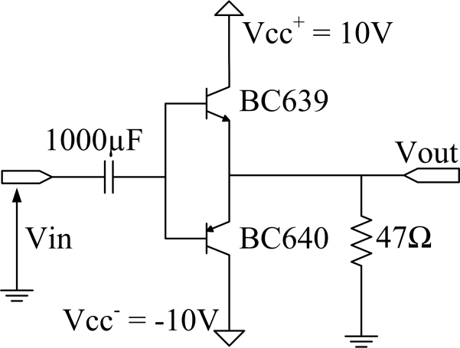

Figure 2

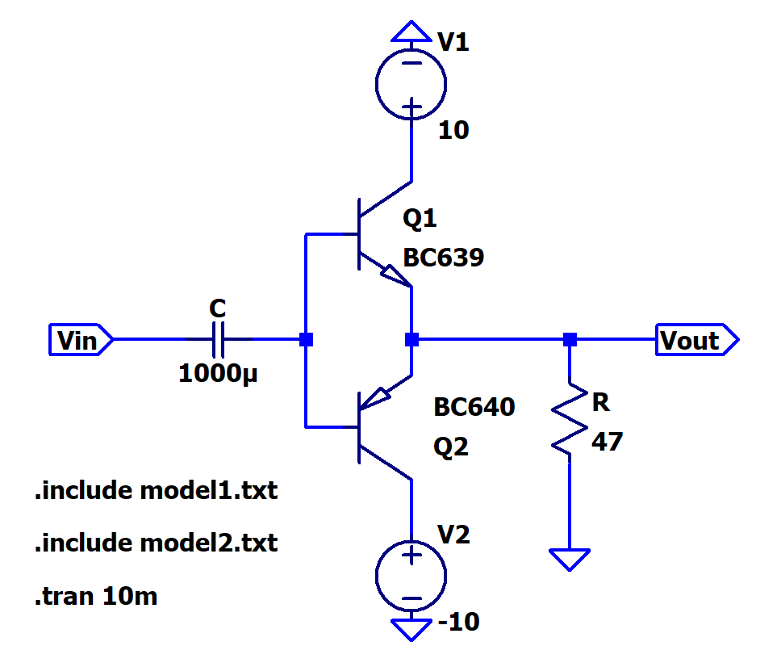

1. Increase the input voltage to the clipping limit & measure the maximum input and output values

VI (max) = 10.69V

VO (max) = 9.9214431V

1. Calculate the efficiency of the amplifier.
$$Input Power\left(P_{IN}\right)= \frac{2×V_{CC}×V_{m(out)}}{π×R_{L}}= \frac{2×10×9.9214431}{π×47}=1.343869542 W$$

$$Power at the load\left(P_{L}\right)= \frac{{(V_{m(out)})}^{2}}{2×R_{L}}= \frac{{9.9214431}^{2}}{2×47}=1.047181204 W$$

$$Efficiency of the amplifier\left(η\right)= \frac{P_{L}}{P_{IN}}=0.7792283189 ≅77.9228 \%$$

2. Observe the cross over distortion at the output, insert Y-T and X-Y mode output plots.

Y-T mode

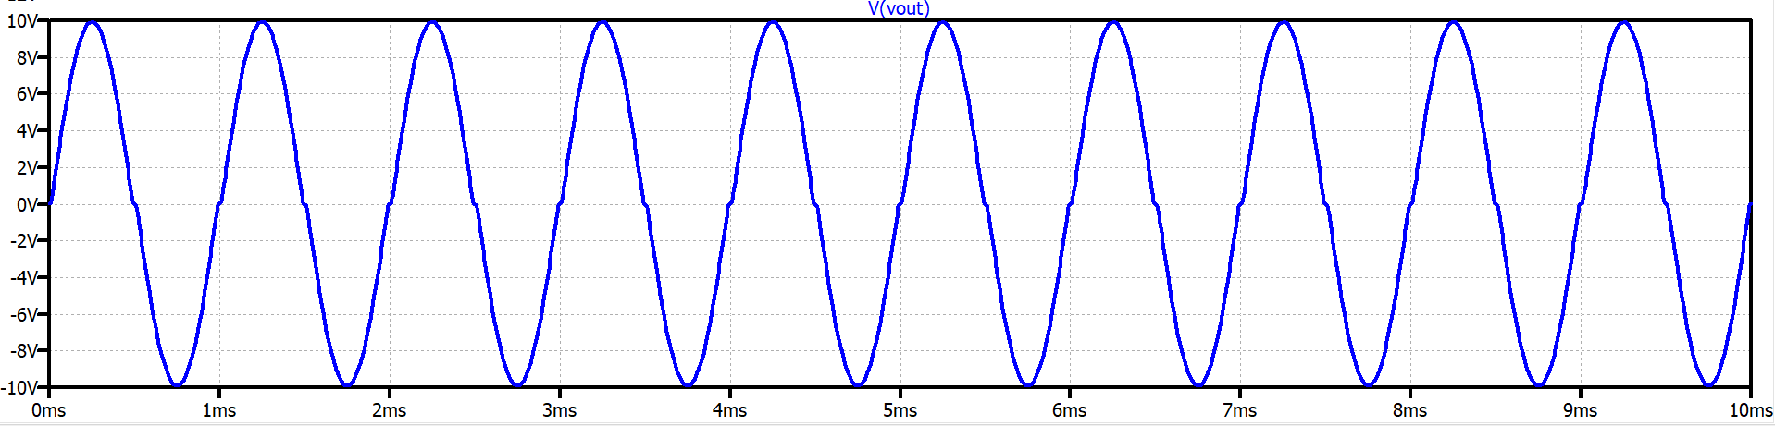

X-Y mode

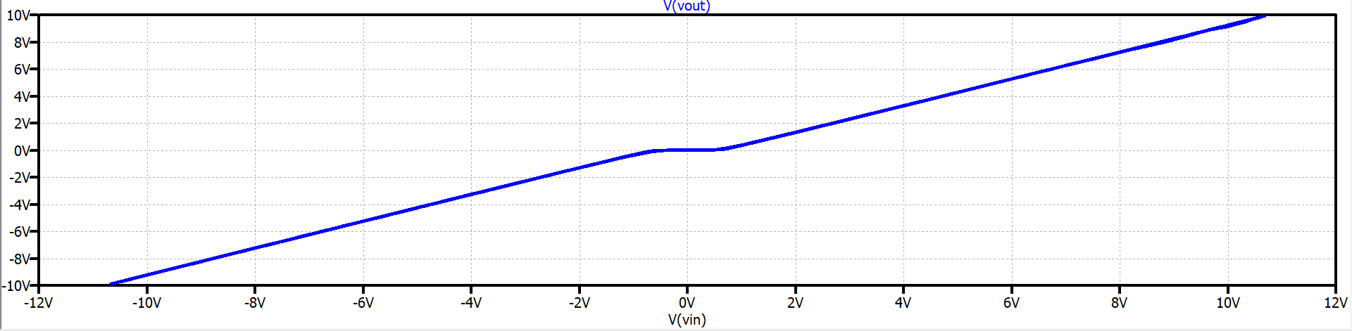

1. Comment on your observations in (d).

By looking at the above two figures, we can observe that the amplifier gives 0V as the output for the input range -582.21495mV to 582.21495mV (approximately). So, we can conclude that input voltage has to be larger than the VBE bias voltage to the transistor to turn on and give an output. So, for the input voltages with a magnitude lower than the bias voltage of the BE junction, output has become zero. This effect is known as the cross-over distortion.

**Simulation 3**: Class ‘**AB**’ Amplifier

1. Connect the offset complementary amplifier circuit as shown in figure 3. Paste your circuit diagram.

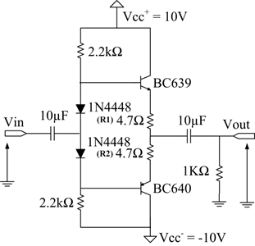

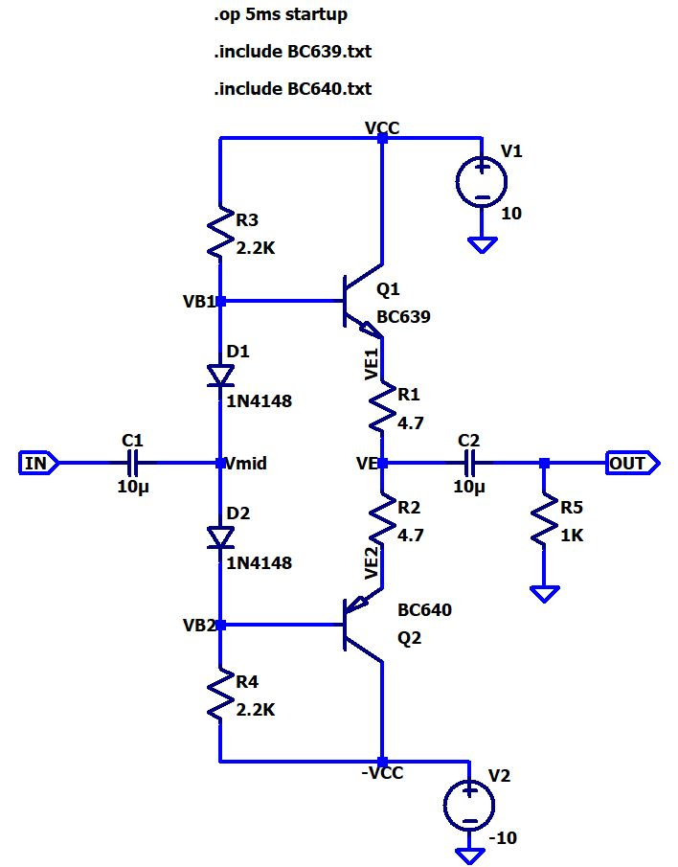Figure 3

1. Using the signal block, adjust the 10 kHz input signal to the maximum output possible without clipping. Adjust *R1* and *R2* to remove the cross over distortion occurring at the output. Measure and note down the maximum voltages.

VI (max) = 9.457V VO (max) = 9.1009244V

1. Calculate the efficiency of the amplifier at this input signal level.
$$η=\frac{AC power decipated at the load}{Power delivered by the DC source}$$

$$η=\frac{P_{L,AC}}{P_{IN}}$$

$$P_{L,AC}=\frac{V_{O}^{2}}{2R_{L}}$$

$$P_{L,AC}=\frac{{9.1009244}^{2}}{2×1000}$$

$$P_{L,AC}=0.0414134W=41.4134mW$$

$$P_{IN}=\frac{2V_{CC}V_{O}}{πR_{L}}$$

$$P_{IN}=\frac{2×10×9.1009244}{π×1000}$$

$$P_{IN}=57.9382mW$$

$$η=\frac{41.4134mW}{57.9382mW}=0.714785=71.4785\%$$

2. Reduce the output to about 60% of the maximum output voltage. Measure and note down the following voltages.

VI = 5.5505V VO= 5.4605192V

1. Calculate the efficiency of the amplifier at this input signal level.

$$P_{L,AC}=\frac{{5.4605192}^{2}}{2×1000}=14.9086mW$$

$$P_{IN}=\frac{2×10×5.4605192}{π×1000}=34.7627mW$$

$$η=\frac{14.9086mW}{34.7627mW}=0.428867=42.8867\%$$

1. Remove the input signal. Using operating point analysis, measure and note down the DC voltages V*B1*, V*B2* and V*E*

VB1 = 651.181mV VB2 = -652.569mV

VE1 = 16.1633mV

VE2 = -17.9814mV

VE = -0.000909041V

***Simulation files can be found at***[*Power-Amplifier/Laboratory Class Equivalent Simulation at main · bimalka98/Power-Amplifier (github.com)*](https://github.com/bimalka98/Power-Amplifier/tree/main/Laboratory%20Class%20Equivalent%20Simulation)*.*